School Development Planning
Alberta Education Outcomes
- Alberta’s students are successful.
- First Nations, Metis, and Inuit students in Alberta are successful.
- Alberta’s students have access to a variety of learning opportunities to enhance competitiveness in the modern economy.
- Alberta’s K-12 education system and workforce are well-managed.

CBE Results Policies
- Results 1: Mission
- Results 2: Academic Success
- Results 3: Citizenship
- Results 4: Personal Development
- Results 5: Character

See the CBE Board of Trustees’ Results Policies for the full and detailed Results statements

CBE 2024-27 Education Plan
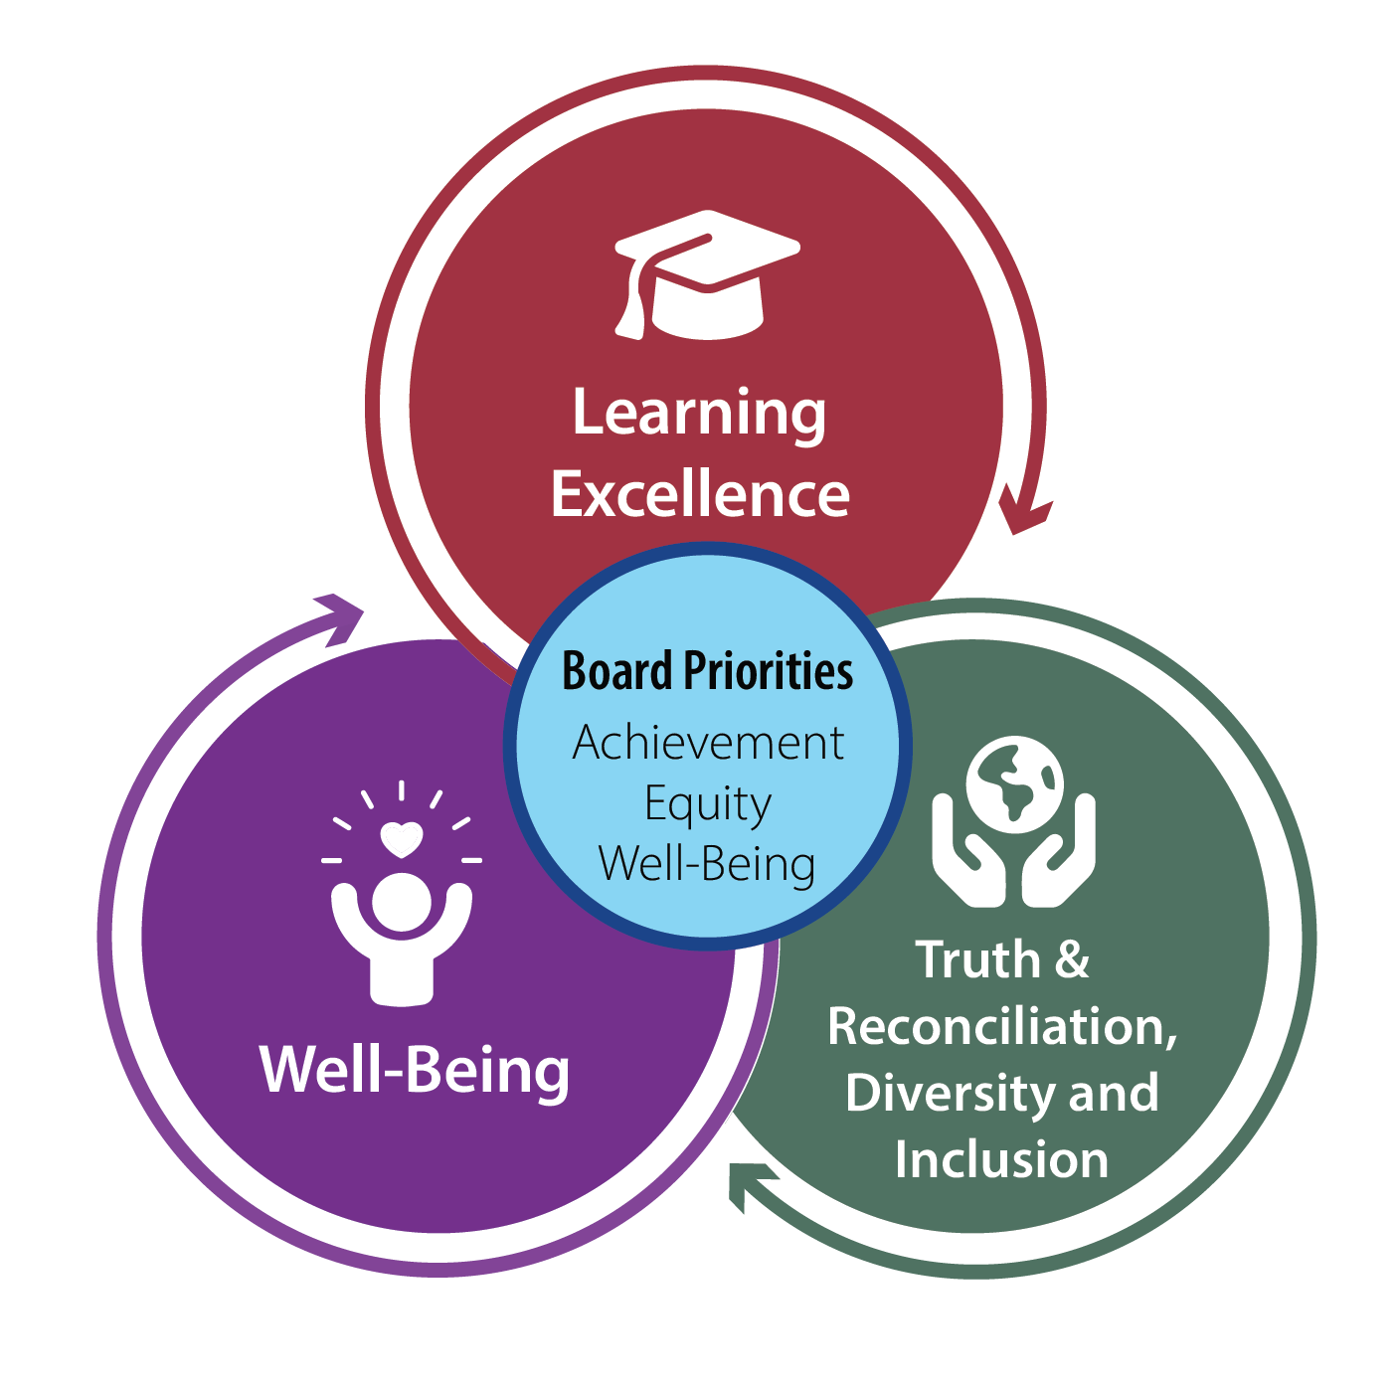
Learning Excellence
Strong student achievement for lifelong learning and success

Well-Being
Students and employees thrive in a culture of well-being

Truth & Reconciliation, Diversity and Inclusion
Students and employees experience a sense of belonging and connection

Introduction
Alberta Education requires each school to create a plan to improve student learning. The School Development Plan (SDP) aligns individual school goals with the identified goals in CBE Education Plan | 2024 - 2027. Each year, schools capture evidence of continuous improvement towards the goals set. In accordance with Alberta Education’s Requirements for School Authority Planning and Results Reporting, schools then provide assurance to school communities by communicating student growth and achievement in a school annual results report. This report demonstrates improvement results and next steps and support continuous improvement of the quality and effectiveness of education programs provided to students while also improving student learning and achievement (Funding Manual for School Authorities 2025-26 School Year p. 213).
The School Development Plan is based on results data relative to the goals and outcomes set in the 2024-25 School Development Plan for Year One and the school’s Alberta Education Assurance Survey results. A summary of the results can be found in the Data Story section of this report. It includes:
- Celebrations
- Areas for Growth
- Identified Next Steps
For detailed results from the 2024-25 School year, please refer to the 2024-25 School Improvement Results Report on our school website.
School Improvement Results Reporting

School Development Plan – Year 2 of 3
School Goal
Student learning improves through fair and equitable assessment practices.
Outcome:
Subject specific fluency will improve, specifically in reading and numeracy.
Outcome Measures  - LeNS (English Letter Name-Sound)  - CC3 (Castles and Coltheart 3)  - PAST (Phonological Awareness Screening Test)  - Numeracy Assessment  - Report Card indicator: Reads to explore, understands concepts related to numbers and patterns (and algebra)  - Grade 6 Provincial Achievement Test |  |  |  |  |  |  |  |  |  | Data for Monitoring Progress  - Teacher Self-assessment (Assessment practices related to reading and numeracy)  - Assessment Criteria analysis (Literacy cycle planning/sharing)  - OurSCHOOL and Assurance Surveys  - Teacher self-reflection on SDP goals (Dec, March, June)  - Math Running Record Assessment for students requiring additional supports
Learning Excellence Actions  - Through the planning of targeted learning cycles, teachers will regularly create and share learning progressions with students  - Teachers will calibrate with colleagues to improve coherent and consistent interpretation of learning goals and student evidence  - Teachers will identify the reading ability and learning needs for each student to guide next steps (phonics/fluency/comprehension)  - Teachers will identify the basic fact knowledge of all students to guide next steps (conceptual knowledge, fluency, application)  - Teachers will use high impacts strategies, such as:  Reading - High-Impact Strategies:  - Regular progress monitoring  - Repeated readings  - Assisted reading activities (choral reading, partner reading, reader’s theatre)  Numeracy  - Daily, Focused practice (targeted skills, number games)  - Math talks and reasoning  - Spaced practice |  |  |  |  |  | Well-Being Actions  - Staff will ensure that students understand success criteria for each student.  - Use multi-modal texts to support multiple entry points, including use of technology  - Access to and use of hands-on manipulatives in math  - Honour student voice and choice with survey of interests/ goal setting |  |  |  |  |  |  | Truth & Reconciliation, Diversity and Inclusion Actions  - Regular review of Truth and Reconciliation Commitment  - Application of Holistic Lifelong Learning Framework in task design and assessment criteria  - Foster student identity as a reader by providing culturally relevant texts, when possible
Professional Learning  - System Professional Learning  - 5 Guiding Principles of Assessment  - Book Study  - High-Impact strategies |  |  |  |  |  | Structures and Processes  School:  - Integrated model that includes: PLC , Collaborative Response, and Teacher Planning  - Regular Grade Team Meetings  - Regular data collection and Review  - Professional Learning Sessions  - Lunch and learns  - Staff meetings  - System professional learning sessions  - Teacher Input/Reflection  - Surveys  - Staff Discussions  Classroom:  - Teacher protocols will include routines, such as:  - Direct instruction  - Modelling  - Independent/ small group instruction  - Flexible groupings  - Math talks |  |  |  |  |  |  | Resources  - Assessment and Reporting  - CBE Literacy Framework  - CBE Mathematics Framework  - Mathematics Equity and Identity Guide  - The 8 Mathematics Teaching Practices  - K-9 | Universal Calibration Protocol  - UFLI Foundations  - CBE Digital Decodable Library  - Grade 4-12 Reading Assessment Decision Tree  - Thinking Routines – 5 Guiding Principles of Assessment  - Team Meetings
School Development Plan – Year 2 of 3
School Goal:
Students’ citizenship will improve.

Outcome:
Students will demonstrate an understanding of how a sense of self and self-regulation impacts their interactions with others.
Outcome Measures  - OurSchool Survey (citizenship)  - Alberta Education Assurance survey (citizenship) |  |  |  |  |  |  |  |  |  | Data for Monitoring Progress  - Students' attendance monitoring  - Student advisory group  - CASEL Student Monitoring (self-awareness, self-management)  - Student self-assessment on peer relationships
Learning Excellence Actions  - Direct instruction of SEL topics in wellness related to respectful interactions  - Regular celebration of learning assemblies with connections to SEL (friendship, positive peer interactions)  - Learning cycle planning that includes  - Clear wellness outcome(s) related to self-awareness, self-management and peer interactions  - Review of wellness learning progressions with students  - Calibration of student work  - Sharing as a staff |  |  |  |  |  | Well-Being Actions  - Establish routines in classrooms to promote self-regulation  - Advertise, encourage and support students to engage in and/or access available clubs and safe spaces during the school year  - Integrate specific wellness goals on IPPs that are guided by the CASEL framework (when appropriate)  - Using whole school data from teachers’ use of “Walk Around Companion Tool” to initiate positive actions toward welcoming, caring, respectful and safe schools. |  |  |  |  |  |  | Truth & Reconciliation, Diversity and Inclusion Actions  - Embed Indigenous connections of respect and reciprocity  - Offering a variety of choice for clubs and recess activities  - Demonstrating respect for diversity through recognition of cultural connections within each class  - Design student and staff tasks that intentionally activate the spirit, heart, body, and mind
Professional Learning  - Build understanding of the Spirit and Heart domains  - CASEL Framework (self-awareness and self-monitoring)  - Public School Works: Social Emotional Learning  - Explore meaning of Indigenous Education Holistic Lifelong Learning Visual |  |  |  |  |  | Structures and Processes  - Integrated model that includes PLC, Collaborative Response, and Teacher Planning  - Grade team meetings  - Clubs  - Regular Student Learning Team meetings  - Use of Comprehensive School Health Approach |  |  |  |  |  |  | Resources  - CBE Student Well-Being Framework  - School connectedness action guide  - CASEL Framework  - Well-Being Team  - Diversity and Inclusion Team  - Indigenous Team  - Public School Works Course

School Development Plan – Data Story

2024-25 SDP GOAL ONE: Student learning improves through fair and equitable assessment practices.

Outcome one: Academic success in reading will improve.

Celebrations
- Foundational reading skills strengthened across most students assessed mid-year.
On LeNS, the percentage of students not at risk increased from 63.2% in November to 77.9% in January (+14.7 percentage points). On CC3, the percentage not at risk increased from 68.9% to 73.5% (+4.6 percentage points), reflecting improvement in decoding and word reading for students in Grade 1-3. In the spring assessment for Kindergarten, the LeNS data showed that 87% of students were not at risk.
- Early literacy readiness is strong across young learners.
PAST phonological awareness results showed that 64–68% of assessed students in both Grade 1 and Kindergarten were not at risk, indicating solid readiness for early reading instruction.
- Students demonstrated reading growth across changing classroom cohorts.
Report card results for “Reads to explore and understand” show increases in Basic, Good, and Excellent indicators from Semester 1 to the Final Report in most grades, reflecting improved literacy proficiency across the school.
- Teachers consistently used shared literacy assessments (LeNS, CC3, PAST, UFLI, Acadience Reading, 4-12 Reading Decision Tree) and aligned these with the reading stem to guide instruction, strengthening the school’s commitment to fair and equitable assessment across classrooms.
- Collaborative planning and assessment tools were developed across the school to create a cohesive understanding of scope and sequence of reading expectations and was developed with fair and equitable assessment across the grades.

Areas for Growth
- A consistent group (20–30%) of students remained at risk on LeNS, CC3, and PAST throughout the year, signaling ongoing needs in phonological awareness, phonics, and decoding.
- High student mobility significantly impacted cohort stability and baseline data.
North Haven draws students from seven neighbourhoods (North Haven, Upper North Haven, Livingston, Carrington, Lewisburg, Lewiston, Keystone Hills) and serves as the overflow school for three nearby schools, meaning students enter and exit the school unpredictably throughout the year.
- Population increases across the year required repeated assessment onboarding.
As new students arrived from multiple intake neighbourhoods, teachers conducted ongoing initial literacy screening, resulting in different assessment group sizes at each checkpoint.
- End-of-year data represent only the subgroup of students with ongoing needs, not the whole cohort. Because June LeNS/CC3 results reflect only previously at-risk students who remained enrolled, they cannot be used as full-cohort comparisons.
- Several grades continue to show a measurable proportion of students at Not Meeting (Indicator 1) on the reading stem, signaling the need for continued intervention and strengthened classroom reading routines.

Next Steps
- Strengthen and formalize assessment cycles (fall–winter–spring) so that all students—especially those entering mid-year—are screened and monitored consistently, despite mobility.
- Implement mobility-aware data practices.
Ensure literacy assessment data are transferred promptly for students moving in/out of the seven intake neighbourhoods and overflow pathways, supporting continuity of instruction.
- Deepen targeted literacy instruction using assessments such as LeNS, CC3, PAST, profiles to guide small-group reading instruction in phonological awareness, phonics, decoding, and application in connected text.
- Continue staff calibration on reading expectations.
Provide ongoing professional learning so teachers share a consistent understanding of CBE reading indicators (Not Meeting, Basic, Good, Excellent) and their alignment with literacy assessments.

- Increase teamwork around data triangulation (classroom tasks – product, conversation, observation), using Collaborative Response or PLC structures to monitor persistent needs and adjust instruction.
- Monitor the at-risk subgroup closely by conducting early (September–October) follow-up checks on the students reassessed in June.

2024-25 SDP GOAL TWO: Students’ citizenship will improve.

Outcome one: Students will demonstrate an understanding of respect for self, others, and place.

Celebrations
- School wide data collection in Social-Emotional Learning Scope and Sequence (SEL) showed strong SEL growth across the school between November and May regarding Self Awareness and Self-Management related to citizenship.
- High student belonging: 83–86% of students reported strong belonging, exceeding Canadian norms.
- Strong cultural and community awareness: 80–86% of students demonstrated understanding of their own and others' cultures.
- Strong peer relationships: 78–86% of students reported positive peer connections.
- Safety above norms: Students reported feeling safer than the Canadian average across all grade levels surveyed.

Areas for Growth
  - Within the school's wide SEL Scope and Sequence data collection one classroom showed an SEL decline, indicating a need for targeted support.
  - Students report needing clearer expectations and more consistent routines linked to respect, safety, and cooperation.
  - When looking at the Alberta Education Assurance Measures (AEAM), Citizenship declined slightly (–0.3 percentage points) from the previous year and remains below the three-year average.

Next Steps
  - Implement consistent SEL instruction across all classrooms using the CBE SEL Scope and Sequence.
  - Strengthen explicit instruction in co-regulation and self-regulation using common language and routines.
  - Embed daily moments for emotional check-ins, problem solving, and restorative practices.
  - Expand cross-grade relationship-building structures to reinforce peer connection and belonging.

  - Increase opportunities for student voice in shaping norms that reflect respect for self, others, and place.
  - Create opportunities for students to see themselves in the SEL instruction and increase self-awareness of their actions and the implications of these actions.

